Final Year Project Report
Half Unit – Final Report

Human Computer Interaction
Cem Ulker

A report submitted in part fulfilment of the degree of
BSc (Hons) in Computer Science with Management
Supervisor: Matthew Hague

Department of Computer Science
Royal Holloway, University of London

Declaration
This report has been prepared on the basis of my own work. Where other published and unpublished source materials have been used, these have been acknowledged.

Word Count:

Student Name:

Date of Submission:

Signature:

Table of Contents
Abstract 2
Project Specification 3
Chapter 1: The Human 4
1.1 Introduction 4
1.2 Human perception 4
1.3 Human Memory 7
1.4 Reasoning 7
1.5 Problem Solving 8
1.6 Conclusion 9
Chapter 2: Interaction and Usability 10
2.1 What is usability? 10
2.2 Why usability is important? 10
2.3 Factors of usability 10
Chapter 3: Design Guidelines 14
3.1 What is Flat Design? 14
3.2 What is Material Design? 16
Chapter 4: Software Sketch 17
4.1 User Stories 17
4.2 Use Cases 18
4.3 Interaction and Usability 18
4.4 Professional Issues 18
4.5 Storyboards 18

Abstract
Since 2007, with the reveal of the first most successful mobile device “iPhone”, the whole mobile device industry has been changed. Almost everyone is whether using a tablet or phone for everyday communication, business, entertainment and much more. What was the key point of this success? There were many devices with touch screens including stylus but what made iPhone so special and touch screens accepted by everyone? This project will be briefly explaining the importance of User Interfaces (UI), User Experience (UX) and the most popular 2 different design languages brought to people’s lives from successful tech companies as Material Design and Flat Design will be discussed. This aims to identify the importance of Human-Computer Interaction (HCI) on a daily basis.
Project Specification
Human Computer Interaction (HCI)
This report will provide relevant background theory on Human Communication Interaction (HCI) concepts. The aim of the project is to compare Material Design, released by Google in 2014 and Flat Design, which gained popularity back in the 1970s. [WEBSITE] Project will also evaluate their design in terms of usability including Nielsen’s heuristics for user interface design. The objective would be to create two car infotainment systems in the same concept but with the following Material and Flat Design guidelines. Following the same concept but different design guidelines will allow us to see which design guidelines are most suitable for user’s ease of use. The storyboards that will be created is a dashboard for car settings adjustment, a climate control panel, multimedia (entertainment) interface for playing and displaying music, video and photo. Also, a brief navigation system will be added to the design. I’m highly motivated to do this project because, in the last couple of years, car manufacturers yet started to realise how important car software will be in near future. Majority of reputational car brands are now hiring qualified, industry specialised software engineers to improve their systems. [WEBSITE] I believe that at the end of this project I will have a wider understanding of how to use guidelines when designing software. Designing car software will allow me to improve and specialise myself in this industry which is one of my long term goals. UAT tests will be done at the end of the project will also allow me to enhance user experience on the designs I create. Having this project as my final year course will show my dedication to this industry in employment processes.
This report would also include prototyping tools used to design a car infotainment system.

The Human

Introduction
The central character in any discussion of interactive systems. Human is the one whom computer systems designed to assist. Since the human is the main factor in our systems, everything should be focused on human (user) requirements and needs. Cognitive psychology is one of the key points to determine how people perceive the environment around them, how they store, process information and solve problems. If the designer has sufficient information about human perception, the designer will also have the ability to manipulate them. There is a correlation between perception and user experience (UX). If a user perceives the environment around better, it will also enhance the user experience. A person’s interaction with the environment occurs through data exchange, similar to computer systems. A computer system is giving output as information by using different types of interaction (display, sound, haptic feedback, etc…) and the user is responding to this output by making inputs to the computer system. In humans, an input is occurring through senses and the output is occurring by motor movements. There are five major senses that a human has; smell, taste, vision, hearing and touch. For now, just three of these senses have major importance in HCI. [BOOK]

Human perception
Perception is the process of collecting various types of sensations and processing them in order to create a meaningful experience for the environment. [1]

Vision:
Vision is one of the major senses that a human has. It is the source of information. The human eye is responsible for receiving light and transforming it into electrical energy for the brain to process the image. Visual perception can be divided into two parts; processing and interpretation of stimulus (brain) and physical reception of stimulus (eye). [MOODLE] The brain processes the visual information alongside with other types of input information from other senses and combining them to create a better perception for the human. Vision by alone allows human to perceive colour, size and depth, shape, brightness, text, font and various other elements that help us to create a better understanding of the environment. This allows designers to manipulate their designs to fit perfect ratios, colour schemes and fonts to appeal user’s attention. To understand how this works, the topics need to be deeply discussed.
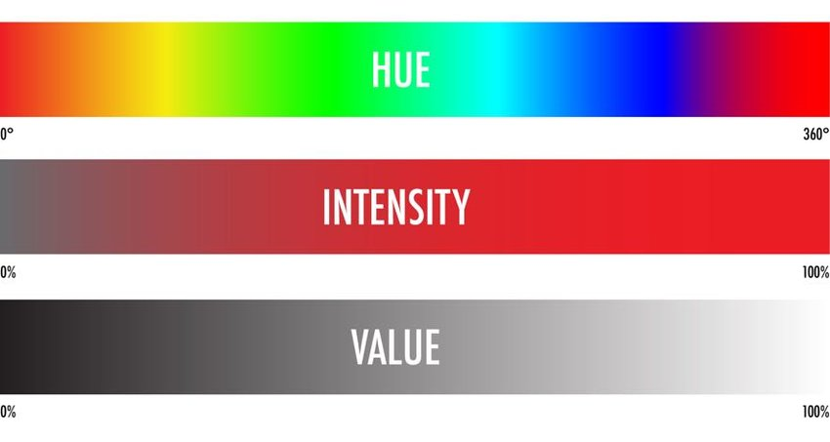
Perceiving Colour – Colour is made up of hue, intensity, saturation. Saturation is the amount of white in the colour, the intensity is the brightness of the colour and hue is determined by wavelengths. The human can perceive approximately 150 different hues. Combining these elements allows us to create 7 million different colours.

Image 1.1 Colour hue, intensity and saturation
Perceiving Brightness – Brightness of an object begins with a light source and luminance. Luminance can be determined by the amount of light falling on an object and its reflective properties. Perceiving light occurs by photons reflecting from an object to the human eye, more photons means more light emitted by eye. A photometer can be used to measure luminance. Those type of sensors being used in mobile devices to adjust the brightness of the screen automatically matching with the environment.[APPLE]
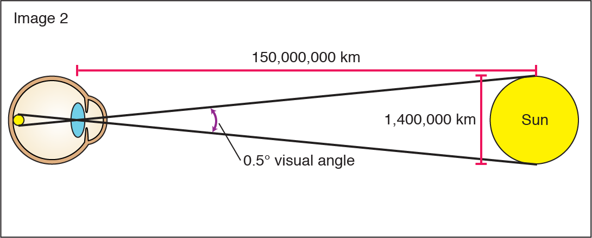
Perceiving depth and size – Every image appears on the retina as upside down even though the reflected light is straight. Size of that image defined as the visual angle. This is affected by the distance of the object and the size. Visual angle illustrates how much space that an object on the field of view. [BOOK] A person with 190cm height can look really tall if the person is close to your visual angle (see the illustration below) but if the same person is further away from your visual angle, they can look really tiny. As in image 1.3 if the sun is much closer to a person’s visual angle, the bigger it will appear to a human eye.
Image 1.2 Visual Angle Illustration with object “Sun”

Hearing:
Hearing is a major sense that human has but it is more likely considered as secondary important sense. Hearing begins with waves and vibrations travelling through the air. Sound is created by changing or vibrations in air pressure. Sound has variety of properties like pitch, amplitude and timbre. [YAZ] Pitch represents the frequency, denser the wavelength means high pitch. Amplitude represents the loudness of the sound, more the amplitude more the loudness will be. Timbre represents type of sound. For example, pitch and the amplitude could be the same for a sound but human ear will hear the sound as two different types if the sound is coming from a piano and guitar. Hearing sounds allow a person to understand the location, distance, direction and the intensity of objects. For example, hearing a car passing by from the street can give information about the direction of the car, how fast it is travelling, the approximate size of the car and from which street it is travelling. The information provided as input is not strong as visual perception.

Touch:
Touch is also one of the major senses that the human body has. It is also called haptic perception. This sense is created by the brain and the nerve system via electrical signals. When human makes contact with an object, the relevant receptors immediately transfer data to the brain as electrical signals (pulses) to allow the brain to process this data alongside with other sensory data to create a better user experience with the outside world. Human has three different receptors in the skin; thermoreceptors, nociceptors and mechanoreceptors. These receptors respond to heat and cold, intense pressure and pain, pressure respectively. HCI studies on mechanoreceptors since humanity don’t have any ready software to simulate pain and temperature on the human body. [2] There are two types of mechanoreceptors and they are so important for HCI. Rapidly adapting mechanoreceptors respond to immediate pressure. Slowly adapting mechanoreceptors respond to continuously applied pressure. [2] Apple has invented “Force Touch” with including Taptic Engine that enables digitisers to distinguish levels of pressure applied to the screen by user while giving feedback.
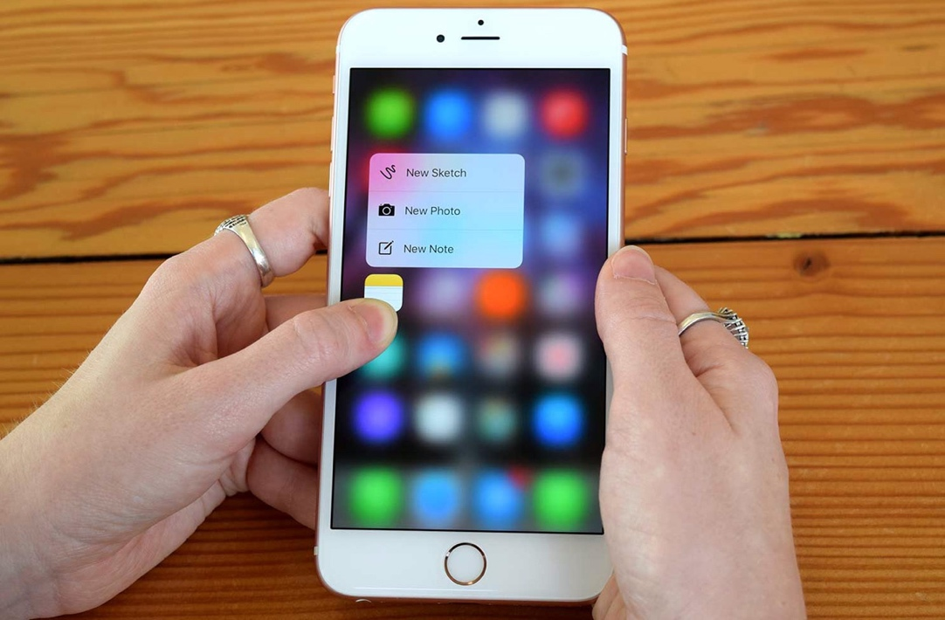

Image 1.3 Force Touch technology on an iPhone 6S
A regular person can test their haptic perception accuracy by two-point threshold test [3]. This can be easily done by taking two pencils and touching them to the thumb. The distance between the two pencils should be around 1cm. Try to increase the distance until you can feel 2 different pencils on your thumb.

Motion:
Human receives information from the environment continuously and reacts according to the information. This action can be auditory or movement. After the human receives information through its sensory receptors and sends the data to the brain for processing. Brain receives the information and gives the order to relevant muscles to make a movement or speech. Total time taken to respond a stimulus defines as “reaction time + movement time” [MOODLE] Moving the cursor to “Skip Ad” button when a person sees an advertisement on YouTube can be an example for this situation. A person can react to pain in 700ms, to visual signal in 200ms and 150ms for auditory signals. [BOOK] Combination of these creates a better and faster response. Also, practise and familiarity can increase the response time. Response time and accuracy are important key elements when designing software for special cases like car infotainment system, medical services, machinery, fire systems, etc… This affects the whole design in terms of usability. Whereas the target buttons should be large and the distance should be the smallest as possible.
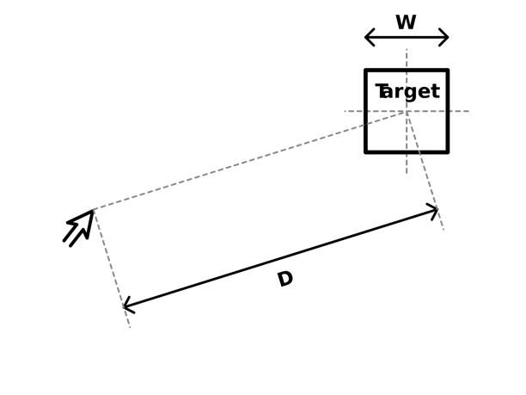
Fitt’s Law – This describes the distance between the initial position of human and target area are related with the target width. Designers can use this law when they’re designing their software. This will increase usability in the entire system. Commonly used items, buttons can be placed near the cursor area and their size could be increased in order to have easy access.

Image 1.4 Fitt’s Law Illustration

Human Memory
While receiving dozens of information continuously from the environment, human also stores this information in the memory to learn and retrieve information when needed. Information stored in memory could be an image, sound, text, smell, taste, movements of a person… etc. There are many variations of information. Memories give human the sense of identity, relationships, language. Every process is associated with memory. What HCI studies with human memory are sensory memory, short-term memory and long-term memory.
Sensory Memory – It is out of cognitive control and it is fully automatic. Continuously overwritten and it has three sub-sensory channels as iconic memory for visual stimuli, echoic memory for auditory stimuli, haptic memory for tactile stimuli. It is responsible to understand actions that are happening in a very short amount of time. This type of memory holds sensory information less than 1 second but this time interval is yet enough for recognising an object, movement, speech.
Short-term Memory – This is responsible for holding information in the memory for a few seconds to recall without receiving the same information again. It is also called ”the working memory”. Short term memory can be accessed rapidly approximately 70ms but it also decays rapidly approximately 200ms so the information stays there for very short time intervals. This type of memory also has a limited capacity. To improve the amount of information to remember, a combination of senses could be used and if the information is visual then the information could be grouped instead of seeing it as chunks.
Long-term Memory – This type of memory stores every kind of information we recognise. Unlike short term memory, it has an unlimited storage capacity, has slower access time which is approximately 1/10 second and also decaying occurs much slower compared to short-term memory. Long term memory is maintained by a more stable and strong neural connection in the brain unlike short term memory which is located on the frontal lobe. Two types of sub long-term memory are in charge of these responsibilities; episodic memory and semantic memory. Episodic memory is storing the experiences and events in serial form. Semantic memory is storing skills concepts and keeps record of the things that human had learned during these events. Semantic memory recalls information from episodic memory.

Reasoning
Human beings are processing any kind of information that they are receiving from the environment at any moment. These received information somehow should be turned into a reasonable knowledge that where reasoning starts to act. Reasoning is the process that received information through different kinds of perceptions turned into conclusions or infer something new about the domain of interest. Reasoning has different kinds; deductive, inductive and abductive reasoning. All of these types of reasoning used in daily basis but each kind have a different structure.
Deductive reasoning – Deductive reasoning, or deduction, starts out with a general statement, or hypothesis, and examines the possibilities to reach a specific, logical conclusion, according to California State University. [15] It is essential not to confuse that logical conclusion must not be always have to correspond to human’s notions of truth. For example;

If it is sunny then the ground is wet
It is sunny
Therefore the ground is wet.

This looks like a perfectly valid deduction even though it is not representing the notion of truth and it conflicts.

Another example ;

Some people are babies
Some babies cry

Most of the people will infer that “Some people cry” which is in fact a wrong deduction. There is no information about all babies are people, therefore it is logically possible that the crying babies are those who are not people. Deductive reasoning is usually misapplied.
In these type of situations the validity and notion of the truth contradicts each other. Human deduction becomes the poorest. Humans use information that they have from the environment as kind of a statement of truth which makes conversations among humans more informative and efficient. If validity is preferred to truth, all statements would have to be made much more explicit.

Inductive reasoning – This happens by making an assumption from the cases and events that a human being has seen before and infer the cases that human had not seen yet. Claiming that every dog has an ear can be true until the time we see or produce a dog without ears. In inductive reasoning, inferences cannot be proven true, they can be proven to be false. The best way to make inductive reasoning is to have evidences alongside with the inference. Despite of inductive reasoning’s unreliability, induction is a very useful process that humans use constantly in learning about the environment. [BOOK] There is no possibility for a human being to see entire history of the dogs to prove they all have ears, but the time period that a human being lives in and experiences the environment can be very useful information to learn about surroundings. Humans are better at using positive evidence rather than negative.

Abductive reasoning – Abductive reasoning typically begins with an incomplete set of observations and proceeds to the likeliest possible explanation for the set. [16] This is the type of reasoning that humans use to derive explanations from the events they observe. Unlikely inductive reasoning, abductive reasoning is more like an action reaction process. For example; we suppose that a software is terminating because of an error without seeing an error message. If we see the same software is terminating again, we would assume that an error happened again, even though we don’t have any evidence. There is a possibility that the process has been completed successfully and the software terminated itself for the reason that it completed the process without a message of confirmation, but we just assumed that the same error happened again. This can lead to problems in using interactive systems. If multiple actions are followed by the same reaction the user would assume the first knowledge that they observed from the environment.

Problem Solving

Human cognition and perception are complicated and refined but they are not without their limitations. Problem solving starts with using the information they have already in the memory with concluding a reasoning behind it. Problem solving is the process where a human being tries to find a solution for a problem that they never encountered before by using their existing knowledge from past experiences. Problem solving is highly related with having the ability to adapt the existing information to the new environment, so it differs from person to person. There are vast amount of research and information about how problem solving works in the brain but we will evaluate the HCI perspective of this information.

Since most of the people are familiar with mobile devices and operating systems nowadays, the guidelines given to developers for their applications can be an example to reduce problem solving process. Universal guidelines allow users to understand the work mechanism of a program even though they are using different multiple apps. Using guidelines are eliminating problem solving process as vast amounts in navigation and interaction. Giving the user interface and navigation styles that users are used to is a good design element for making a user to understand the infrastructure with no need of a user manual. This will be discussed more in the usability chapter.

Conclusion

In this chapter, human perceptions, memory and reasoning are explained in detail in order to have understanding of what aspects of this information correspond in HCI. We have considered that human is an information processor which gets inputs from the environment through the perceptions every human being has and responds correspondently with creating an output. This process happens by storing this information received through receptors and organs in either temporary, sensory, working memory or permanently in long-term memory. This information then used in reasoning and problem solving. Having all of this information about the central character in any discussion of interactive systems allows designers to understand how they implement this valuable knowledge into their systems. Since human is the one whom computer systems designed to assist, understanding of how interaction mechanism works also allows designers to manipulate these processes without letting the users know about it.

Interaction and Usability

What is usability?
Usability in general, refers to ease of access and/or use for a product. Usability can be evaluated by doing tests in real environments with users that never used the product that has being tested. Even tough usability seems to be an easy study, when it’s studied in HCI everything starts to get complex. HCI and usability standards have been developed over the past 15 years with the beginning of personal computing. Researches have shown that there are many factors that affect usability directly. Consistency, memorability, ease of learning, efficiency of use are some types of factors that affect usability over a product. Usability highly related with human perception for the fact that giving an information clearly allows human being to rapidly adapt and understand the context and generate a response accordingly. Giving only the relevant information by not including the climate controls on the screen at every time by reducing confusion and giving the right information clearly in this case could be an example to this.

Why usability is important?
Over the last 15 years, a comprehensive range of international standards has been developed to define the general principles of user-centred design and good practice in user interface design. [17 CP] After the big market of enterprise computing, individuals had started to interact with computer and this resulted in vast amount of researches in this topic. Having a standard of usability in cross-platforms allowed regular user to easily adapt their existing knowledge to newer systems in enormously growing computer industry. One of the biggest innovations made in personal computer industry was switching from old terminal interfaces to WIMP (windows, icons, menus, pointer) style interaction. Switching from terminal to WIMP style allowed every user not to be computer specialists but regular users that have no common sense about computers to use computer systems without requiring any kind of information. Since we are making a car infotainment system, we will be using touch interfaces for the best result and that’s why usability is very important for this case.

Factors of usability
A usable interface should consist on three main elements; the software should be easy to understand and navigate for a user when they firstly encounter with the product. The user should achieve their goals within the application without having any problems and difficulties. Lastly, the software should be easy to recall in terms of design and structure to make it memorable at any time. Combination of these elements creates good usability. Following factors should be examined to achieve great HCI.

Visual Factors
Font Size and Colour – Font texture can differ in many ways depending on what operating system they work on, what kind of displaying device used to display fonts and the environments that users look at the fonts. Using uppercase, lowercase fonts with font pairing can help user to understand the context more easily. Including paragraphs with distinguishable titles and sub headings are often good for clear understanding of the context. Using sans-serif fonts on car infotainment system for example, is much better because it is often better to read on the screen whereas serif fonts can be much better at paper. [MOODLE] Even though yourself did not realise that all of these factors are applied to this research paper, you can clearly distinguish the importance levels of information just with brief look.



Image 1.5 Sans Serif “Akzidenz-Grotesk” font

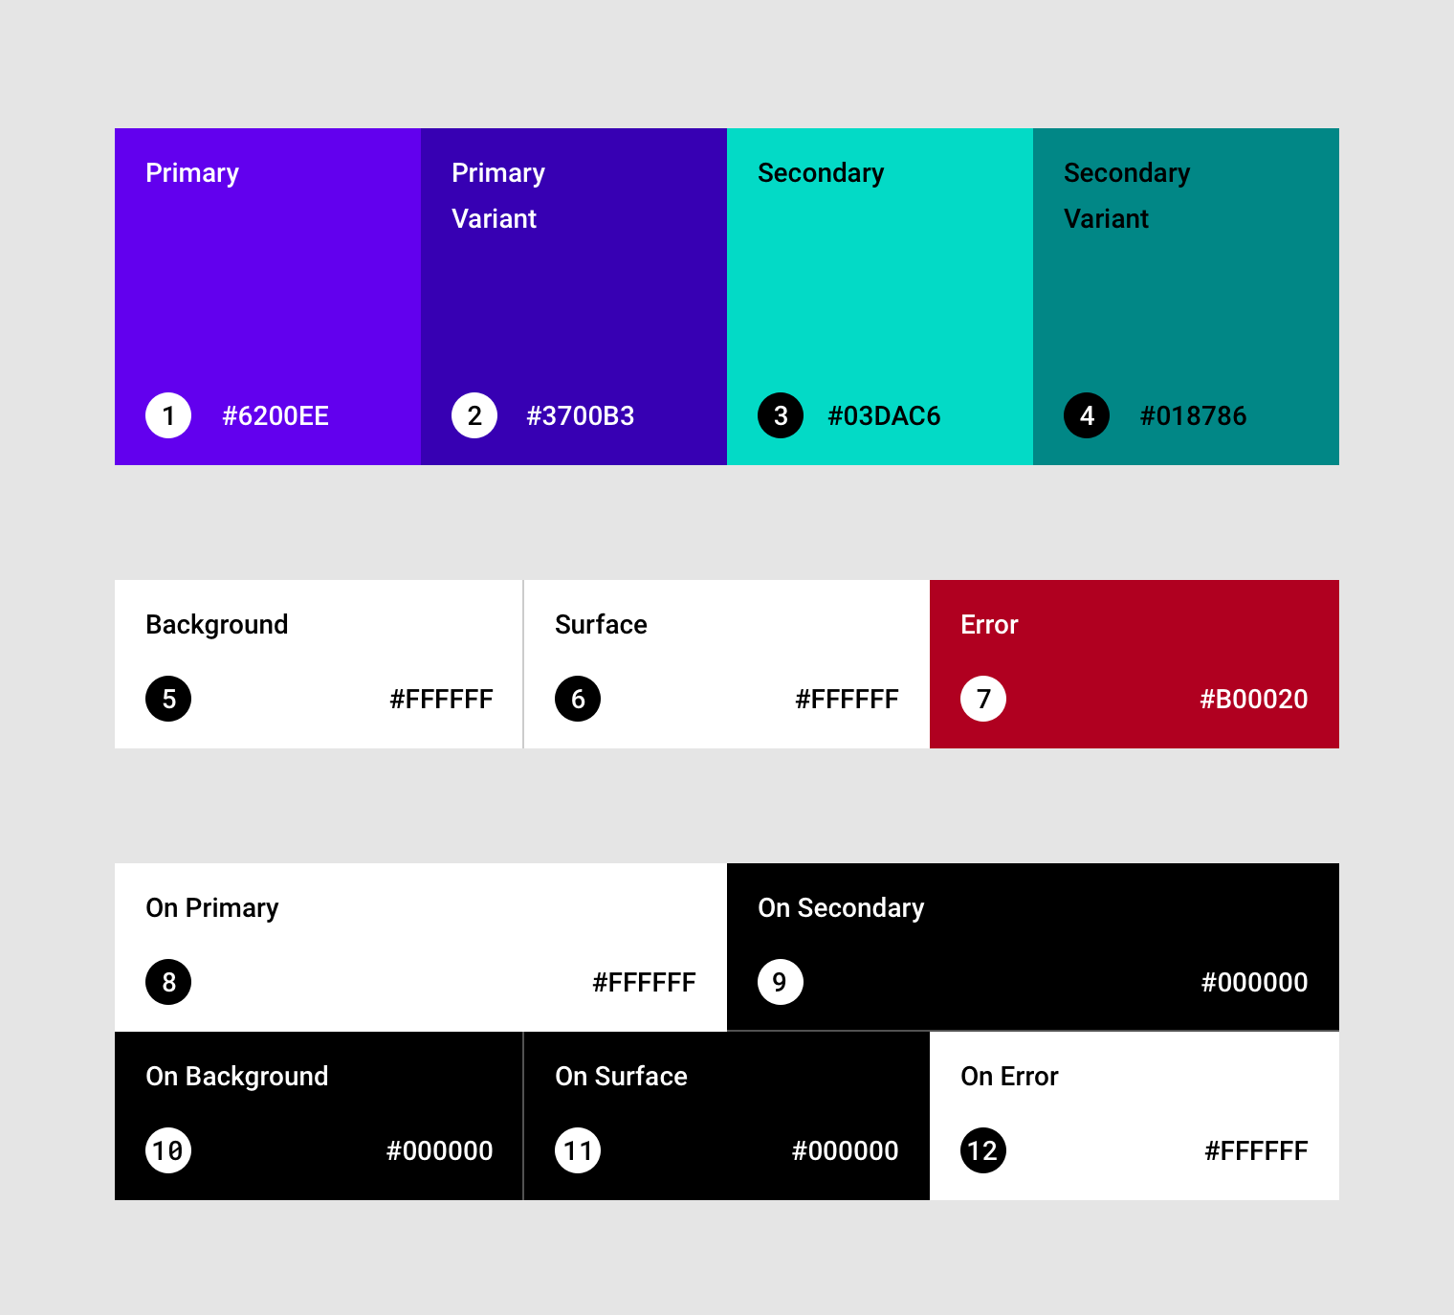
Layout Colours – Colour schemes used in software can distinguish elements, buttons to appeal user’s attention whereas wrong colour schemes can result in difficulty of reading, not distinguishable elements and bad usability. For this reason, this is also one of the crucial factors that must considered before making a design.
Image 1.5 The baseline Material Design colour theme
Navigation – For users to get the most from a software, they need to get from point A (the entry point) to point B (where they want to be) as quickly and easily as possible. That means providing useful navigation systems, including voice recognition, to facilitate that transition. [18CP] This factor is holding a very crucial importance in car infotainment system because navigating through functions should be easiest as possible not to distract driver from the road. Navigation types can be examined as three different groups;
Linear
- Linear navigation systems only allow the user to navigate through the interface in one way.
- Linear systems are normally non or minimally interactive, with start, next and back buttons but no others.
- Linear systems are the most structured of all the topologies.
Hierarchical
- A hierarchical based site is similar to a family tree in that every page has a parent page.
- Each page has only one path leading to it.
- The structure of sites of this type is very rigid, but can be useful for organisations with discrete departments requiring a section each.
- Breadcrumb trails can also be used in a hierarchical site.
Webbed
- A webbed topology allows the user to navigated in a more fluid fashion.
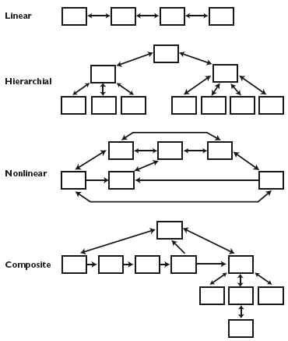
- The range of webbed topologies is quite broad, ranging from almost hierarchical with additional links, to where each page will link to others of similar or related topic but where there is no underlying categorisation by topic.[19]

Image 1.7 Navigation types used in modern software

Satisfaction – An interface that satisfies the user is often considered having good usability. To check that the interface is satisfactory to the user, UAT testing could be done. These tests would be based on the user stories. The users could also do an interview or take a survey to give feedback about the system. User acceptance testing (UAT) is the last phase of the software testing process. During UAT, actual software users test the software to make sure it can handle required tasks in real-world scenarios, according to specifications. UAT is one of the final and most critical software project procedures that must occur before newly developed software is rolled out to the market. UAT is also known as beta testing, application testing or end user testing.

Design Guidelines
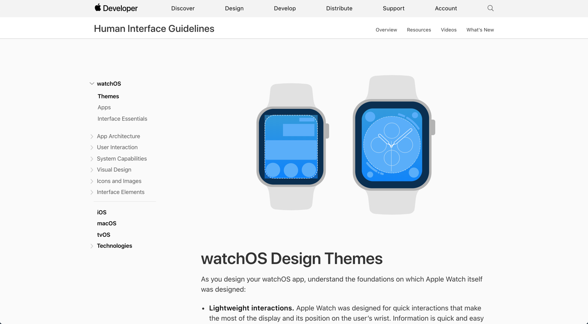
To achieve good design, some standards should be identified and set to developers. Human interface guidelines are designed to help designers and developers create a beautifully consistent experience on whatever operating system (OS) or software they are working with.[13] These type of guideline targets to improve user experience and consistency. They can have limited definitions on design languages but it also needs to be considered that not every application is working on the same environment and system. Following these guidelines as a developer are a must for most of the big companies when working on SDK’s but for some companies or open-source systems, it is not that applicable. Policies are sometimes based on studies of human–computer interaction, but most are based on conventions chosen by the platform developers preferences. [14]

Image 1.5 Example of Human Interface Guidelines for a mobile device

What is Flat Design?
Flat design is a user interface design style that uses simple, two-dimensional elements and bright colours. It is often contrasted to the skeuomorphic style that gives the illusion of three dimensions through copying real-life properties. Its popularity became prominent with the release of Windows 8, Apple’s iOS 7, and Google’s Material Design, all of which utilize flat design. Flat design was originally developed for responsive design, where a website’s content scales smoothly depending on the device’s screen size. With the use of simple shapes and minimal textures, flat design ensures that responsive designs work well and load fast (especially important since mobile devices have slower internet speeds). By reducing the amount of visual noise (in the form of textures and shadows), flat design provides users with a streamlined and more optimal user experience. [12]
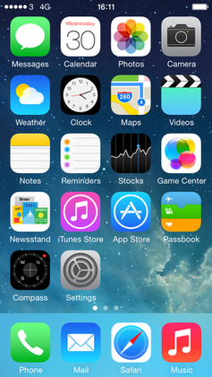

Image 1.5 Apple iOS 7 as example for Flat Design

Issues with the Flat Design
However, despite its popularity, flat design also has drawbacks regarding the user experience. The absence of three-dimensional effects (e.g., drop shadows) takes away the cues that indicate how a user can interact with a design. For example, buttons in the flat design style do not appear distinct from other visual elements on a webpage, and therefore do not appear clickable. Because of this danger, flat design is increasingly applied in a more balanced way, often referred to as “flat design 2.0” or “almost flat design.” This trend takes the clean and simple visuals from flat design and adds some subtle skeuomorphic qualities such as colour variations and shadows. With this increased depth and dimension, visual variety increases and usability improves. For instance, Google’s Material Design and Apple’s iOS interfaces heavily use shadows and/or blurring effects to make their interfaces more intuitive to use. [12]

What is Material Design?
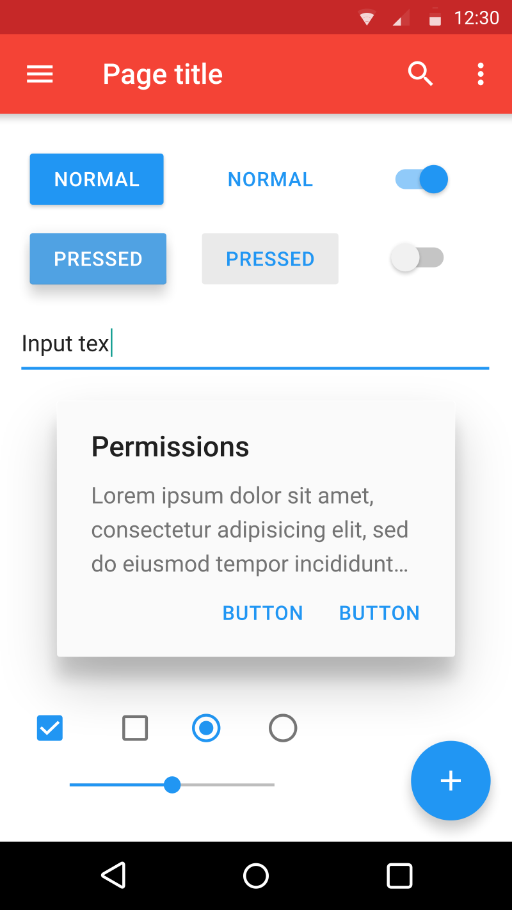
Designed and released by Google in 2014 to be used firstly in Google internal applications. After internal development, Google allowed 3rd party users to implement the same design language by releasing guidelines to public. Material design uses shadows, depth effects, padding and it is mostly based on grid layouts. Material design arise from the problems that popular design language flat design has. It focuses on every individual item to set their level of priority. Most commonly used buttons, texts or items will be placed on top of a layer with different tone of the same colour with a touch of shadow, allowing to distinguish items from unnecessary ones. Material Design is based on paper and ink, Google says. The implementation of the design takes place in an advanced manner.

Image 1.6 Material Design, founded by Google Inc.

Software Sketch

User Stories
A user story is a high-level, detailed definition of requirements just containing enough information to inform developers about user needs.
• As the driver, I would like to have a simple, minimalistic design, so I can easily adapt to design.
• As the driver, I would like to see control the air conditioner, so I can easily change temperature.
• As the driver, I would like to see travel information, so I can know when to fuel up.
• As the driver, I would like to play music, so I can entertain everyone in the car.
• As the driver, I would like to access my contacts, so I can have phone conversations.
• As the driver, I would like to have voice recognition, so I can command with voice.
• As the driver, I would like to have machine learning, so the car learns my habits and settings.
• As the driver, I would like to have NFC pairing system, so I can easily transfer data, profile.
• As the driver, I would like to have Apple CarPlay and Android Auto, so I can integrate with the mobile device.
• As the driver, I would like to link my phone with the navigation system, so I can see live traffic information and various details over the touch screen.
• As the driver, I would like to see the album, title and artist of the song, so I can easily access information.
• As the driver, I would like to have a multi-destination trip entry, so I can be less distracted along travel.
• As the driver, I would like to have a tire-pressure management system, so I can increase security and get notified.
• As the driver, I would like to have a hotspot system, so I can get a wi-fi connection for my devices.
• As the driver, I would like to use multiple apps at once, so I can get informed without distracting myself with switching over pages.

Use Cases
DIAGRAM

Interaction and Usability
Information

Professional Issues
Making emergency button not large or appeal
Putting button in the wrong place in fire management system and deploying water springs.

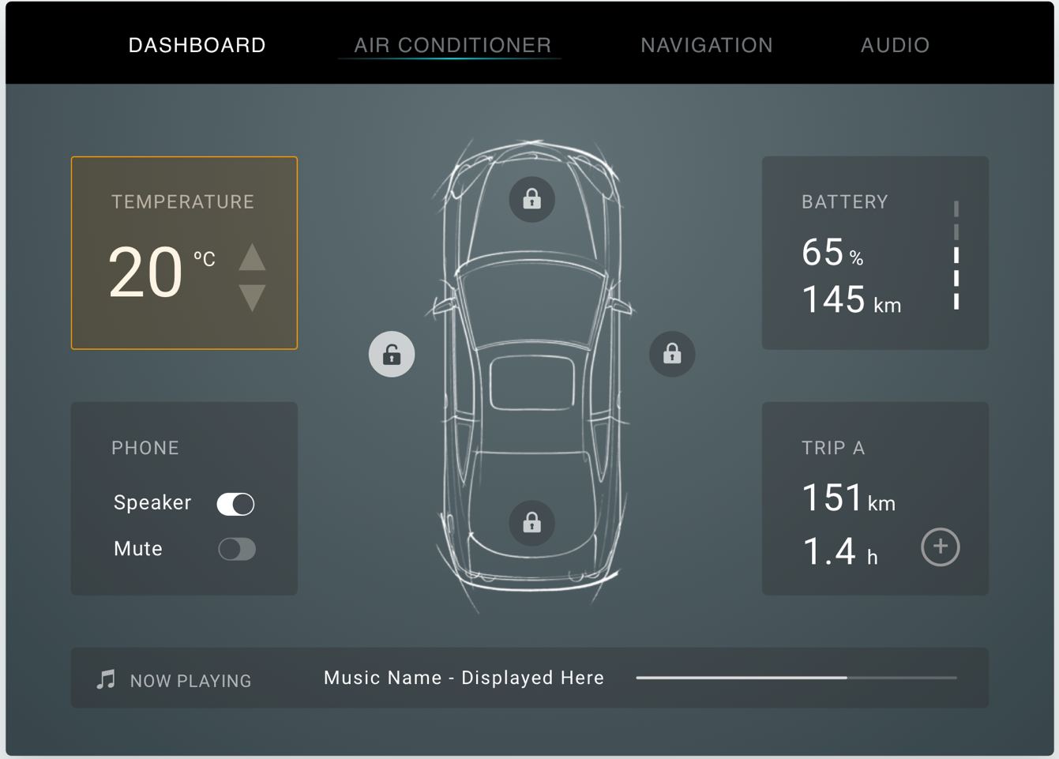
Storyboards
Image 1.5 Main “Dashboard” Screen

Final Year Project Presentation;

Why I choose this project ?
- I believe in the power that showing people what they need to buy and manipulating them.
- Users don’t know what they need and interact with
- Manipulating these minds would be much easier with visual aspects.
- I can drag users attention wherever I want
- The most important human perception is visual so it is the best way to manipulate

Brief overview of HCI and design languages

Why Flat and Material Design?
-Most popular design languages in this decade
- Providing wide range of use without designing the tools for the software
- Guidelines making it better
- Universal design language
- Can be customisable for every need and sue

Why I did a car infotainment system ?
- Car industry is changing from top to toe
- Most of the corporations are hiring many UI, UX designers to make their systems more efficient and user friendly
- There are many potentials on the industry because it is in baby steps now
- Autonomous systems will be worldwide and this can be a good step
- Luxurious terms in the car industry is turning to software side instead of materials used in the interior

What my system provide?
- More sales and marketing to the customer
- Tech systems are more appealing then traditional buttons
- It can be customisable however a car manufacturer needs
- The system can be expandable to two screens but this will increase costs
- Main focus is to produce 3rd party affordable infotainment solutions
- Making a standard over car manufacturers

Bibliography :
- https://www.interaction-design.org/literature/book/the-glossary-of-human-computer-interaction/perception#chapter_start
- https://pdfs.semanticscholar.org/1e1c/631b51116a784f096dd10972018082911ec4.pdf
- https://backyardbrains.com/experiments/skin
- https://en.wikipedia.org/wiki/Fitts%27s_law
- https://www.toptal.com/designers/interactive/amazing-vehicle-ui
- https://www.behance.net/gallery/23771657/Tesla-Interface-Concept
- https://medium.com/@oberhaeuser/it-s-time-for-car-infotaiment-interfaces-to-arrive-in-2015-edc061f8300
- https://www.figma.com/blog/what-teslas-model-three-ui-reveals-about-its-vision-for-the-future/
- https://www.nngroup.com/articles/ten-usability-heuristics/
- https://www.creativebloq.com/graphic-design/what-flat-design-3132112
- https://www.cognitiveclouds.com/insights/connected-car-practical-use-cases/
- https://www.interaction-design.org/literature/topics/flat-design
- https://elementary.io/docs/human-interface-guidelines#human-interface-guidelines
- https://en.wikipedia.org/wiki/Human_interface_guidelines
- https://www.livescience.com/21569-deduction-vs-induction.html
- http://www.butte.edu/departments/cas/tipsheets/thinking/reasoning.html
- https://ac.els-cdn.com/S1071581901904835/1-s2.0-S1071581901904835-main.pdf?_tid=30297820-0a41-465c-94f9-ea7b3d7c5536&acdnat=1551629674_cd74a99bca73ddee30d192141bc67db2
- https://www.interaction-design.org/literature/topics/usability
- http://hci.ilikecake.ie/des_navigation.htm
Pictures ;
https://en.wikipedia.org/wiki/Fitts%27s_law#/media/File:Fitts_Law.svg
https://www.google.com/search?q=visual+angle+akademik&source=lnms&tbm=isch&sa=X&ved=0ahUKEwi0lsKr1NTgAhUtSBUIHbAVCqEQ_AUIDigB&biw=1439&bih=748#imgrc=FNdUzTKgF-pkUM:

